Aberdeen Baptist Lui Ming Choi College
School Nominations Direct Admission Scheme (SNDAS) for 2026/27 Academic Year

Objective
It is a “programme-student matching exercise” in essence that provides opportunities for secondary students who have demonstrated exceptional talents and interests in specific disciplines / areas to be considered for direct admission to local universities.

For detail, please visit:
https://www.edb.gov.hk/en/edu-system/postsecondary/policy-doc/SNDAS/index.html

Number of nominations : TWO

Programmes to be covered
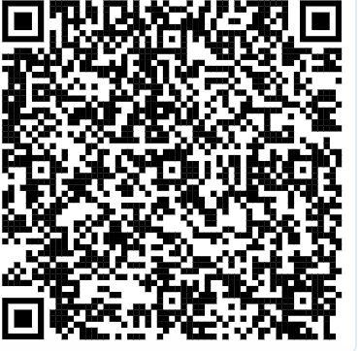
The eight UGC-funded universities have designated a total of over 200 publicly-funded undergraduate programmes to participate in the second cohort of SNDAS.
Please click the following link for the programmes and specific requirements of the programmes.
https://www.edb.gov.hk/en/edu-system/postsecondary/policy-doc/SNDAS/designatedprogrammes_2026-27.html

Requirements for application
(a) Local students pursuing the local secondary curriculum and taking the 2026 HKDSE Examination; and
(b) MUST apply for admission to universities through the Joint University Programmes Admissions System (JUPAS) in parallel.
(c) Student nominees MUST include the chosen SNDAS-participating undergraduate programme as one of their 20 JUPAS programme choices.
(d) Participating universities may also require student nominees to include their chosen SNDAS-participating programme as one of their JUPAS Band A programme choices. Please study the specific admission requirements for each participating programme.
Note: Students nominated for the School Principal’s Nominations Scheme (SPNS) under JUPAS will NOT be eligible for nomination under SNDAS, and vice versa.

Application arrangement
- Each student nominee can apply for admission to ONE designated University Grants Committee (UGC)-funded undergraduate programme participating in SNDAS.

- Participating universities will arrange interviews for ALL students nominated for SNDAS to assess the suitability of the nominees for specific programmes between January and early June 2026. Written / practical assessments may also be arranged.

Announcement and Acceptance of Offers
- If you are successfully nominated by School Principal, participating universities will make firm offers to successful SNDAS student nominees in June 2026, prior to the release of the 2026 HKDSE Examination results.

- Successful nominees MUST decide whether to accept the offer BEFORE the release of the 2026 HKDSE Examination results. Once accepted, the firm offer will be binding and the nominees WILL NOT be considered / accepted by other programmes regardless of their HKDSE Examination results. Their JUPAS applications will automatically be removed from the JUPAS application system. Successful nominees who have accepted the firm offer will commence study for their chosen programme in September 2026.

- For unsuccessful nominees (i.e. those who did not receive / rejected the SNDAS offer), their JUPAS applications will continue to be processed and be considered by the JUPAS-participating institutions for admission to their programmes following the release of the 2026 HKDSE Examination results.

Important dates

- Deadline： 10 NOV 2025 (23:59)
- Email the completed application form to phyeung@ablmcc.edu.hk
- Hand-written application form is NOT accepted.
- You will receive a confirmed message on or before 11 NOV 2025. If not, please contact Ms Yeung.
- Date of the interview by Principal : To be informed (before end of November)

Aberdeen Baptist Lui Ming Choi College
School Nominations Direct Admission Scheme(SNDAS) for 2026/27 Academic Year

APPLICATION FORM

Personal Details

Name: _________________________________(In English) ___________________ (In Chinese)

JUPAS Application No.: _________________________ Class :__________ No.: __________

Phone No.: _____________________(Home) _____________________ (Mobile)

Identity Card No.: ____________________________ Date of Birth:＿＿＿＿＿＿＿＿＿＿＿＿

Note : your school email address will be used in communication.

- Choice of Programme

Designated programmes in the 2026/27 academic year
https://www.edb.gov.hk/tc/edu-system/postsecondary/policy-doc/SNDAS/designatedprogrammes_2026-27.html

Course (Full name)
JUPAS Code
University

- Self-Assessment
- Please refer to the programme admission requirements and copy the requirements for self assessment. (You need to print out the programme admission requirements and application requirements as supporting document.)
Reference:
https://www.edb.gov.hk/tc/edu-system/postsecondary/policy-doc/SNDAS/designatedprogrammes_2026-27.html

Programme Admission requirements:
 | Requirements | M=Mandatory  P=Preferred  O=Optional | Put a tick (✓) if you satisfy the requirements. Add comments if necessary.
(a)
(b)
(c)
- Application requirements:
Will you put your chosen programme in Band A? ____________
- Extra-curricular activities and Achievements of Past 3 years (22-23, 23-24, 24-25)
Fields | Year | Names of Activities | Awards
Sports
Music
or
Other forms of performing arts
Language, Creative Art and writing
Math, Science and STEM
Leadership abilities
Social Services
Others
(Scholarships,…)
- Self-recommendation Letter
The letter MUST explain why you are a suitable candidate for the programme and provide support with solid evidence.

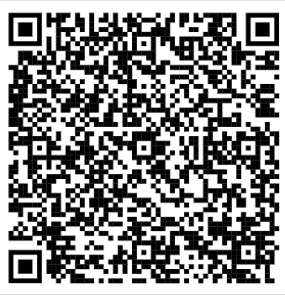
- Supporting documents

- Scan all relevant supporting documents in pdf format (as a single pdf file).
2. Print out the Programme Admission requirements and Application requirements of the applied programme from SNDAS website.
Reference:
https://www.edb.gov.hk/tc/edu-system/postsecondary/policy-doc/SNDAS/designatedprogrammes_2026-27.html

If you fail to provide supporting documents, you will NOT be considered for the interview.

注意：
1. 申請表：word document
2. 獎項
- 請掃描後，並結合成一個pdf 檔 (切勿寄出多個單獨檔)
- 若是獎牌/獎杯，請影相，之後變成pdf檔，並與其他pdf 檔結合成一個pdf 檔
3. Programme admission requirements and application requirements of the applied programme : 可以是一個獨立pdf 檔

